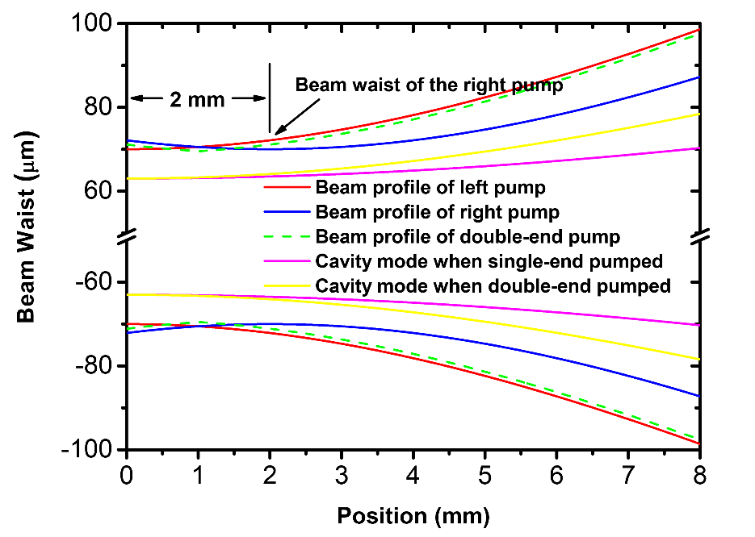

Fig 1. Beam profile of the pump and intra-cavity mode under single-end pumped and double-end pumped schematic in the gain media.

As depicted in Figure 1, generally speaking, by employing diode-double-end pumped structure, the beam waist and divergence angle of the pump profile increased, resulting in a larger part of the gain media involved in the lasing process, which contribute to a more vibrant laser performance.

To be specific, by utilizing Spiricon M2-200, for the pump source being focused by the 50 mm focusing lens, the beam waist and M2 were measured to be ~70 μm and 4.3, respectively. The displacement of the focusing points of the two pumps were measured to be ~2 mm. The beam profiles of the left and right pump in the laser crystal, which has a length of 8 mm, are depicted by the red and blue lines. The total pump profile under double-end pumped schematic is shown by the green dashed line. For intra-cavity mode, when the system was single-end pumped, the beam waist and M2 were measured to be ~63 μm and 1.2, while under double-end pumped schematic, the beam waist remained almost unchanged and M2 raised up to 1.8. The beam profiles of the cavity mode under single-end pumped and double-end pumped schematic are plotted by the magenta and yellow lines.

By introducing volume integral method, the overlapping efficiencies, which is described by the division of the volumes of cavity mode and pump accordingly, were calculated to be 66% and 72% under single-end pumped and double-end pumped schematic, respectively. That is to say, by making use of double-end pumped schematic, the overlapping efficiency increased, leading to an increased slop efficiency and better laser performance.